Water - Glycol Air Coolers



**INSTALLATION, OPERATION AND MAINTENANCE INSTRUCTIONS**

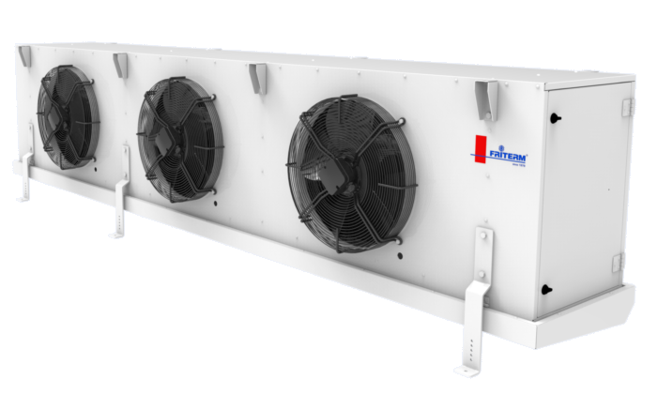



GCS Series

*www.friterm.com*

CONTENTS

[1. ABOUT THIS MANUAL 1](#_Toc89095398)

[1.1. Examining the operating manual 1](#_Toc89095399)

[1.2. Responsibilities 1](#_Toc89095400)

[1.2.1 Manufacturer’s Responsibilities 1](#_Toc89095401)

[1.2.2 Contractor’s Responsibilities (Installation, Commissioning) 2](#_Toc89095402)

[1.2.3 Operator’s or Owner’s Responsibilities (Operation and Maintenance) 2](#_Toc89095403)

[1.3. Warranty 3](#_Toc89095404)

[2. SAFETY REGULATIONS 4](#_Toc89095405)

[2.1. Symbols and Warning Signs 4](#_Toc89095406)

[2.2. Personal Protection 5](#_Toc89095407)

[2.2.1 Personal Protection Sign 5](#_Toc89095412)

[2.2.2 Warning Signs 6](#_Toc89095414)

[2.3. Warnings 6](#_Toc89095415)

[2.4. Improper Use 7](#_Toc89095416)

[2.4.1 Hazardous Rotating Machinery 7](#_Toc89095417)

[2.4.2 Hazardous Voltage 7](#_Toc89095418)

[2.4.3 Hazardous Thermal 8](#_Toc89095419)

[2.4.4 Hazardous refrigerant 8](#_Toc89095420)

[Ethylene glycol is flammable and explosive at high temperatures. 8](#_Toc89095421)

[Keep away ethylene glycol from fire. 8](#_Toc89095422)

[2.4.5 Ultraviolet 9](#_Toc89095423)

[2.5. Environmental Protection 9](#_Toc89095424)

[3. LABELLING 9](#_Toc89095425)

[3.1. Product Code 9](#_Toc89095426)

[3.2. Type Plate 10](#_Toc89095427)

[3.3. Friterm Logo 10](#_Toc89095428)

[3.4. UV – C Lamb Caution Ticket 10](#_Toc89095429)

[4. TECHNICAL DATA 11](#_Toc89095430)

[4.1. Standards 11](#_Toc89095431)

[4.2. Product 11](#_Toc89095432)

[4.3. Fans 11](#_Toc89095433)

[4.3.1 Fan Connection Diagrams 12](#_Toc89095434)

[4.4. Sound Pressure Level 17](#_Toc89095435)

[4.5. Heater Connection Diagrams 18](#_Toc89095436)

[4.5.1 Diagrams 18](#_Toc89095437)

[4.6. UV – C Lambs 21](#_Toc89095438)

[4.6.1 Connection Diagrams 21](#_Toc89095439)

[5. TRANSPORT AND STORAGE 21](#_Toc89095440)

[5.1. Check for Completeness and transport damage 21](#_Toc89095441)

[5.2. Transport 22](#_Toc89095442)

[5.3. Storage 24](#_Toc89095443)

[6. INSTALLATION 24](#_Toc89095444)

[6.1. Location 24](#_Toc89095445)

[6.2. Requirements at the Setup Point 25](#_Toc89095446)

[6.3. Mounting 25](#_Toc89095447)

[6.4. Electrical Connection 30](#_Toc89095448)

[7. OPERATION 30](#_Toc89095449)

[7.1. Initial Commissioning 30](#_Toc89095450)

[7.2. Regular Commissioning 30](#_Toc89095451)

[7.3. Defrost System 32](#_Toc89095452)

[7.3.1. Defrost Control 32](#_Toc89095453)

[7.3.2. Circulation Air Defrost 32](#_Toc89095454)

[7.3.3. Electric Defrost 33](#_Toc89095455)

[7.3.4. Hot Gas Defrost 33](#_Toc89095456)

[7.3.5. Water Defrost 34](#_Toc89095457)

[7.4. UV-C Lamb 35](#_Toc89095458)

[7.5. Shutting Down 35](#_Toc89095459)

[8. MAINTENANCE 36](#_Toc89095460)

[8.1. Maintenance Intervals 36](#_Toc89095461)

[8.2. Fan motor Maintenance 36](#_Toc89095462)

[8.3. Maintenance of UV-C Lamb 37](#_Toc89095463)

[8.4. Periodical Controls (Once a year) 37](#_Toc89095464)

[8.5. Cleaning 37](#_Toc89095465)

[9. TROUBLESHOOTING 39](#_Toc89095466)

# ABOUT THIS MANUAL

This document specifies the instructions for installation, operating and maintenance of the air coolers (GCS series) manufactured by FRITERM A.Ş., Turkey.

The instructions below must be followed strictly for the health and safety reasons during installation and maintenance of products.

Upon receipt, the product should be visually inspected, and in case of any damage or fault, the supplier must be notified within 7 days.

The manufacturer will not accept any responsibility in these situations;

* Damages caused by persons,
* Damages product due to the disregarding of the recommendations indicated in this handbook.

## Examining the operating manual

To follow the instructions defined in this document is a prerequisite for safety of the staff and for the products to be operated in a fault-free and safe manner.

* The operating manual must always be available. In case of absence of this manual another copy could be obtained from the manufacturers’ web page. It should be printed out and kept in an accessible place to everyone whoever should carry out any work regarding the product.

(<http://www.friterm.com/en-US/catalogue/unit-air-coolers/water-glycol-standard-unit-coolers/2/10058> )

* All persons who are responsible for the transport, assembly, initial commissioning, operating, maintenance or repair of the component must be acquainted with the operating manual. The operator should accept in written form that they are acquainted with the operating manual.
* Whenever you have difficulty in understanding and/or comprehend and description or definition given/expressed in this manual, please immediately ask for help from an expert or from then manufacturer. It is of great importance to understand this manual completely and correctly for the sake of labor health and safety.

## Responsibilities

### 1.2.1 Manufacturer’s Responsibilities

* The manufacturer is strictly responsible for supplying a manual accompanying the product which comprises the necessary and enough detailed information regarding the installation/mounting and operation of the product. Besides, the product is expected to fulfill the requirements and satisfy with the anticipated functioning.
* The construction of the product should comply with the presumed operational conditions. The product is expected to be robust enough and resistive against all the mechanical, thermal and chemical challenges. The material used to produce should be compatible with the fluid and the mixture of fluids used as heat transfer media.
* All the materials and components used in constructing the product should be resistive against all the stress and pressure that the product will be subjected to.

### 1.2.2 Contractor’s Responsibilities (Installation, Commissioning)

* Should follow all the instructions and provide all the conditions stated in this manual.
* All the documentation accompanying the product are complementary to this manual. The safety instructions and all other information stated in this manual should be considered.
* The national regulations regarding the protection of environment and labor safety should be strictly followed besides the instructions for safe and correct operation.
* In case of any problem encountered during the installation, FRITERM A.Ş. should be informed and asked for technical assistance if necessary.
* Emergency instructions and the required infrastructure should be prepared and ready for use in any case.
* The regular maintenance/servicing periods and instructions should be determined and defined.
* If storage of the product for a long period is needed, a clean, non-hazardous and low humidity environment is recommended.
* The fans of the products that are stored horizontally are recommended to be run for 4-5 hours a month. In case of difficulty of running the fans, then they should be covered and protected from rain and excess humidity.
* In case of storing vertically, it is not recommended to store more than 1 month.

### 1.2.3 Operator’s or Owner’s Responsibilities (Operation and Maintenance)

* The director is the responsible person who employs the adequate staff for servicing operating and monitoring the system.
* All requirements and instructions in this operating manual must be complied with.
* The documentation of purchased products is a constituent part of this operating manual. All safety information in this operating manual and all other information must be observed.
* All relevant regulations concerning accident prevention and environmental protection must be complied as well as the confirmed technical regulations for safe and proper working.
* Personal ineligibility. All the work should be conducted by authorized and trained staff.
* Any defect/damage/malfunction caused by disregarding the instructions given in this manual is the responsibility of the operator.
* Any defect/damage/malfunction caused by the misuse of the product is the responsibility of the operator.
* The product should not be put in operation without the completion of the installation and commissioning.
* The personnel who is responsible for the operation/servicing/maintenance of the product should be provided with all the necessary documentation including this manual.

## Warranty

* The manufacturer warrants that the equipment delivered to the client shows no defects caused by failure of design, material, manufacturing and/or workmanship within the warranty period.
* The client must notify in written form within 10 days from the receipt of the goods, any perceptible defect including transport damages. For hidden defects, he/she must notify the defect in written form and in details within 10 days from observation time.
* Unless otherwise agreed, the warranty period shall be 24 months starting from the date of delivery. The warranty period will start counting down if the product(s) is stored in manufacturers place more than one month.
* The warranty does not cover defects in the product’s operation stemming from a fault in materials or parts provided by the client, nor shall it cover an installation that has not been assembled according to the manufacturer’s instructions and according to professional practice.
* The warranty shall not cover equipment and/or its accessories if they have been modified by the client without manufacturer’s written consent.
* The warranty clause can only be invoked by the client if the equipment is used normally and in conformity with its purpose and manufacturer’s instructions.
* The manufacturer’s liability hereunder shall be limited to repair, modify or replace the parts or equipment that shows defect within the limitation of the items under this article.
* The warranty period of the repaired or modified or replaced parts or equipment shall in no way extend the warranty period of the original ones.
* The works resulting from the warranty conditions shall be carried out in the manufacturer’s workshop after the client has sent the defective equipment or parts for repair or replacement.
* The manufacturer’s responsibility is strictly limited to the obligations as stipulated herein and it is expressly agreed that he shall not be found to make any other indemnity. In particular, he shall in no case be liable to compensate loss caused directly or indirectly by a defect in the equipment delivered.
* The product should be installed and commissioned in accordance with the national/international regulations and rules.
* The power supply which the product is supplies should not deviate 10% from the values given on the label.
* This document and annexed given installation, operation and maintenance conditions as long as the warranty specified in the sales contract is valid.

# SAFETY REGULATIONS

## Symbols and Warning Signs

The following terms and/or symbols are used in the operating manual for particularly important information.

Safety messages and symbols are quoted at the relevant positions in the operating manual if there is danger such as death, personal injury and environmental damage. These safety warnings must be strictly adhered to.

|  |  |
| --- | --- |
|  | Indicates a hazardous situation which, if not avoided, may result in death or serious injury. |
|  | Indicates a hazardous situation which, if not avoided, may result in serious injury. |
|  | Indicates a hazardous situation which, if not avoided, may result in moderate or minor injury. |
|  | Additional notes, information and tips. |

|  |  |
| --- | --- |
|  | IN CASE OF DANGER! |

* Switch off the power
* Switch off the main
* Please ask assistance from an authorized technician or expert.
* Please do not try to resolve any problem by trial and error.

## Personal Protection

While working on and standing by the product, protective clothing and goggles must be worn.

|  |  |
| --- | --- |
|  |  |

* Goggles
* Safety shoes
* Safety helmet
* Protective gloves for fitting and repair work
* Chemical-resistant clothing and protective gloves for cleaning work, especially when handling solvents
* Safety goggles for cleaning work, especially while handling solvents or using compressed air for cleaning
* Hearing protection



### 2.2.1 Personal Protection Sign

|  |  |  |  |
| --- | --- | --- | --- |
|  | Head Protection |  | Eye Protection |
|  | Foot Protection |  | High Visibility Clothing |
|  | Protective Clothing |  | Hand Protection |
| C:\Users\lenovo 2\Desktop\respiratory.PNG | Respiratory Protection |  |  |



### 2.2.2 Warning Signs

|  |  |  |  |
| --- | --- | --- | --- |
|  | No Smoking |  | Flammable |
|  | High Voltage |  | Hot Surfaces |
|  | Hand İnjuries |  | Poisoning Danger |
|  | Fire Risk |  | Frostbite Hazard |
|  | Explosion Potential |  | Corrosive Substances |
|  | Automatic Start-Up |  | Irritant Substances |
| C:\Users\ferhatcanbas\AppData\Local\Microsoft\Windows\INetCache\Content.Word\processed-beea7c2f-17ae-4a2c-b2a6-52fe81c5fc47_QFgRiKv6.jpeg | UV-C Lamb |  |  |

## Warnings

* In an unexpected situation use the emergency stop button which is set up on an easily accessible place.
* Do not exceed maximum operating pressure given on the unit’s type plate.
* Unless the advised safety devices available or fully active the unit must not be operated.
* Set up the unit with extreme cleanliness.
* The unit must not be operated if it is damaged. FRİTERM A.Ş. must be informed about all damages.
* The unit must be installed, operated and maintained by authorized/qualified personnel only.
* Units are design to be used with a proper coolant like ethylene glycol, propylene glycol etc. In case of using any other coolant may cause damage, leakage, danger and environmental pollution.
* No modification is allowed on the product without written permission from the manufacturer.
* Operational conditions are limited within the specified range by the manufacturer. In case of need to operate the product out of the range, a confirmation should be asked from FRITERM A.Ş.

## Improper Use

Danger of injuries in improper using;

|  |  |
| --- | --- |
|  |  |

### 2.4.1 Hazardous Rotating Machinery

|  |  |
| --- | --- |
|  | Danger of cutting hands and fingers. Lids should be unscrewed by an authorized technician. |
|  | Use hand protection. |
|  |  |

### 2.4.2 Hazardous Voltage

|  |  |
| --- | --- |
|  | Electrical voltage can cause serious injuries or death. Do not contact with voltage direct or indirect. Do not forget to power off the unit before you begin maintenance work. |
|  | Activate the electrical system and secure against switching on again before starting installation, maintenance and repair work. |
|  |  |

### 2.4.3 Hazardous Thermal

|  |  |
| --- | --- |
|  | Danger of burns and frostbites. |
|  | The danger of frostbite can occur in case of high volume leakage during maintenance or because of defect. Since the pressure of liquid refrigerant will drop suddenly down to atmospheric pressure (uncontrolled expansion) the temperature will drop well below zero which may cause frostbites on skin. Protective gloves should be used. |
|  |  |

### 2.4.4 Hazardous refrigerant

|  |  |
| --- | --- |
| C:\Users\lenovo 2\Desktop\respiratory.PNG | Ethylene glycol is an itching and irritating coolant when it contacts with skin or eyes directly. In this case, it is recommended to use a gas mask. |
|  | As toxic combustion products may form, the fluid must be protected from ignition. Care must be taken to ensure that the atmosphere is ventilated. |
|  | No Smoking |
|  | Ethylene glycol is flammable and explosive at high temperatures.Keep away ethylene glycol from fire. |
|  | Ethylene glycol is flammable and explosive at high temperatures in the vapor and gas phase. |
|  |  |

### 2.4.5 Ultraviolet

|  |  |
| --- | --- |
| C:\Users\ferhatcanbas\AppData\Local\Microsoft\Windows\INetCache\Content.Word\processed-beea7c2f-17ae-4a2c-b2a6-52fe81c5fc47_QFgRiKv6.jpeg | Avoid exposition to UV-C rays emitted by the germicidal lamps,  even for few seconds, it may cause severe conjunctivitis and  erythema |
|  | You must wear a protective gloves |
|  | UV-C lamp is very high energy lamps. If you do not take an advocate precaution it can be permanent eye damage. Cause you must wear protective goggles |
|  |  |

## Environmental Protection

While handling the product, it has to be ensured that materials which can endanger the environment are disposed of properly. Service materials must not be allowed to enter the sewerage system and the underground water system.

All relevant national regulations concerning environmental protection and the technical issues for safe and proper working must be complied.

# LABELLING

## Product Code

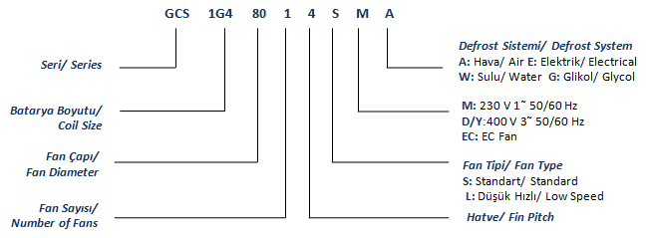

## Type Plate

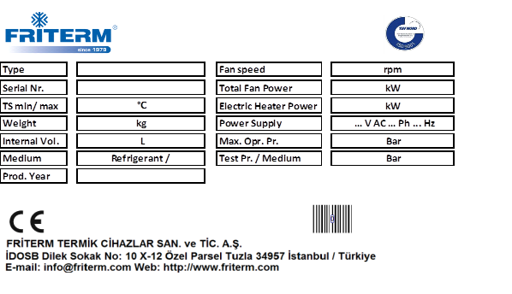

## Friterm Logo



## UV – C Lamp Caution Label

|  |  |
| --- | --- |
|  | Ultraviolet (UV) Radiation Inside.  Exposure may cause eye damage.  Do not operate without coverings.  Do not look into UV source.  Wear UV eye protection |
|  | High intensity ultraviolet energy.  Protect your eyes and skin |
| These labels are located on the side of the fans. Not available on all products. If a UV-C lamp is selected as an accessory, it is included with the product. | |

# TECHNICAL DATA

## Standards

* 2014/68/EU PED (Pressure Equipment Directive)
* TS EN 378 “Refrigeration systems and heat pumps, technical safety and environmental requirements”
* Capacity standard for evaporators is defined according to the EN 328 standard (Test procedures for establishing the performance of forced convection unit air coolers for refrigeration)
* The system installer is responsible for that the inherent installation and security information are harmonized with the valid standards and guidelines (DIN EN 292 / 294).

## Product

The basic principle is to transfer the thermal load of warm air in the room to the refrigerant by the aid of a heat exchanger employing axial fans. Its working principle is that the air blown by fans cools down by the refrigerant evaporating within the tubes while passing through the fins.

The unit is designed and delivered to the end user for operation at a specific operating point.

## Fans

* High efficient axial Ziehl Abegg, EBM or equivalent fans are used.
* Fan diameters: 300/ 350/ 400/ 450/ 500/ 630/ 800 mm.
* 400V 3~50/ 60Hz, 230V 1~50/ 60Hz
* Three phase fans can work at two different speeds. Furthermore, providing speed control is optional for EC fans.
* Variable fan speed regulation can be achieved using three phase fans with frequency inverter and sine filter.
* Variable voltage speed control system could be used as an alternative fan speed control system.
* All motors are suitable for speed control applications up to 100 %.
* All motors have feature internal thermal protection.
* Standard wiring of all motors are for one speed.
* Working temperature for exterior mounting is between -40 ºC and +50 ºC - +70 ºC.
* Fans are designed with assuming fans working Fans run in a housing designed to maximize air flow.
* Recommended starting for motors is 6 starts per hour, maximum starting for motors is 10 starts per hour.
* In case of prolonged stoppage of system, run the fan motors at least 4 hours per month.
* Motor protection IP54; insulation class F.
* Friterm reserves the right to use fans of different manufacturers. Depending on the type, the fan data may slightly vary.

### Fan Connection Diagrams

* + - 1. **EBM Fan Connection Diagrams**

|  |  |  |
| --- | --- | --- |
| *EBM 230V Internal Thermistor EBM Fan (1 Fan)* | | |
| EBM 230V *Internal Thermistor Fan Connection* (2 Fan) | | |
| EBM 230V *Internal Thermistor Fan Connection* (3 Fan) | | |
| EBM 230V *Internal Thermistor Fan Connection* (4 Fan) | | |
| EBM 230V *External Thermistor Fan Connection* (1 Fan) | | |
| EBM 230V *External Thermistor Fan Connection* (2 Fan) | | |
| EBM 230V *External Thermistor Fan Connection* (3 Fan) | | |
| EBM 230V *External Thermistor Fan Connection* (3 Fan) | | |
| EBM 230V *External Thermistor Fan Connection* (4 Fan)    EBM 230V *External Thermistor Fan Connection* (4 Fan) | | |
| EBM 400V *Thermistor Fan Connection* (1 Fan) | | EBM 400V *Thermistor Fan Connection* (2 Fan) |
|  | For the products with 3 fans, one 1 fan diagram and one 2 fan diagram should be used, For the products with 4 fans, two 2 fan diagrams should be used. | |

* + - 1. ***Z. ABEGG Fan Connection Diagrams***

|  |  |  |
| --- | --- | --- |
| Z.ABEGG 230V Suction/Blowing Fan Connection (1 Fan) | | |
| *Z.ABEGG 230V Emme/Basma Fan Bağlantısı (2 Fan)* | | |
| *Z.ABEGG 230V Emme/Basma Fan Bağlantısı (3 Fan)* | | |
| *Z.ABEGG 230V Emme Fan Bağlantısı (4 Fan)* | | |
| *Z.ABEGG 230V Basma Fan Bağlantısı (4 Fan)* | | |
| *Z.ABEGG 400V Fan Bağlantısı (1 Fan)* | | *Z.ABEGG 400V Fan Bağlantısı (2 Fan)* |
|  | For the products with 3 fans, one 1 fan diagram and one 2 fan diagram should be used.  For the products with 4 fans, two 2 fan diagrams should be used. | |
|  | Electrical fan connection diagrams shown in the table are for standard serial products. The other suitable fans could be installed based on the same diagrams. Product catalogue could be referred for fan number and diameter. | |
|  | Installation of the product while the thermistor connection must be done. Otherwise, fan failures and overheating can be encountered similar problems. | |
|  | When the hoods on the fan heater used, the heating system must be work in operation during defrost and other operation time. | |

## Sound Pressure Level

Noise pressure levels (LpA) are determined from the sound power levels (LwA) by using following formula according to EN 13487 Surrounding Surface Method.



Sp = parallelpiped surface (3 m)

Sr = Surface reference (1m2)

Sound pressure levels given shows the average values on a parallelpiped surface at 3 m distancce from the unit in open air over a reflecting plain.

|  |  |
| --- | --- |
|  | The values given in the table are only for giving an idea of magnitude; the actual values might vary depending on the environmental conditions and installation characteristics. |

Table of sound pressure level

|  |  |  |  |  |  |  |  |
| --- | --- | --- | --- | --- | --- | --- | --- |
| **Fan Diameter (mm)** | **Fan Speed (rpm)** | **Sound Power Level LwA dB(A)** | **Number of Fan** | **1** | **2** | **3** | **4** |
| 800 | 890/ Δ | 79 | **Sound Pressure Level dB(A) (Distance at 3 m)** | 57 | 60 | 62 | 63 |
| 690/ Y | 74 | 52 | 55 | 57 | 58 |
| 630 | 1340/ Δ | 90 | 68 | 71 | 73 | 74 |
| 1070/ Y | 85 | 63 | 66 | 68 | 69 |
| 630 | 900/ Δ | 74 | 52 | 55 | 57 | 58 |
| 720/ Y | 69 | 47 | 50 | 52 | 53 |
| 500 | 1330/ Δ | 77 | 55 | 58 | 60 | 61 |
| 940/ Y | 71 | 49 | 52 | 54 | 55 |
| 450 | 1310 | 68 | 47 | 50 | 52 | 53 |
| 900 | 61 | 39 | 42 | 44 | 45 |
| 400 | 1430 | 74 | 52 | 55 | 57 | 58 |
| 870 | 59 | 37 | 40 | 42 | 43 |
| 350 | 1340 | 64 | 43 | 46 | 48 | 49 |
| 910 | 53 | 32 | 35 | 37 | 38 |
| 300 | 1320 | 61 | 40 | 43 | 45 | 46 |

## Heater Connection Diagrams

### 4.5.1 Diagrams

Electric defrost heater connection diagrams show as follows.

|  |  |  |  |  |
| --- | --- | --- | --- | --- |
|  | |  | |  |
|  | |  | |  |
|  | | |  | |
|  | | |  | |
|  | | |  | |
|  | | |  | |
|  | Since there is no neutral phase in the ships, the neutral phase is not energized. | | | |
|  | Please refer to product catalogue for the heater power. The difference in current between two phases is allowed to be at most the ampere drawn by a heater. | | | |
|  | The heaters are fixed with segments. The segment plier should be use to disassemble segments before removing heaters. When the heater is replaced by a new one, the segments must be fixed again. | | | |
|  | The electrical connections must comply with related specifications and the earthing connection must be made carefully and elaborately. | | | |

## UV – C Lamps

### 4.6.1 Connection Diagrams

|  |  |
| --- | --- |
|  | Protect the power supply cable from high temperature, sharp corners, water, oils.  The electrical supply power of this device is 220-240V, 50/60Hz. |
|  | It is recommended a hour counter to indicate when the UV lamp is next to exhaust its life cycle. |

# TRANSPORT AND STORAGE

## Check for Completeness and transport damage

* Attention! May cause severe injuries or unrecoverable damages in case of uncontrolled fall down.
* Instructions on lift and transportation should be strictly followed.
* Check if there is any damage on product or package. Immediately after receipt, the delivery must be inspected for possible transport damage. Any damage must be reported immediately to the shipping company. If it is to be expected that the transport damage may affect proper operation, then the product must not be commissioned.
* Upon receipt, the product should be visually inspected, and in case of any damage or shortage, the supplier should be notified within 7 days.

## Transport

The product may only be lifted and moved by persons who:

1. are authorized to operate crane systems,
2. are authorized to drive motorized handling product
3. Also know the transport and lifting instructions according to the operating manual and the assembly drawing.

|  |  |  |
| --- | --- | --- |
|  | **Suitable transport equipment must be used.** | |
| Figure 1- Transport Position | | |
|  | **Only lift the packed unit with a forklift with full work length.** | |
| **FALSE** | | **TRUE** |

|  |  |
| --- | --- |
|  | **Risk of accident due to falling load.** |

The size and weight of the product may cause accidents while transporting

* Be extremely careful during transport to avoid damage or deformation on the product.
* Only use suitable transport equipment and lifting gear with sufficient load-bearing capacity.
* All precautions should be taken against any possible mechanical risk.
* Never stand or work under suspended loads.
* Wear appropriate protective clothing (helmet, safety gloves, safety shoes).

|  |  |  |
| --- | --- | --- |
|  |  |  |

* During lifting, a suitable lifting tool like a forklift or a crane is to be operated as in the drawings below. When lifting the product with hauling hooks, it is necessary to use a lifting beam connected to the hooks.
* Product is mounted with wooden beams at the bottom. It can be placed on the ground on these wooden beams. These wooden beams provide enough height for forklifts. During landing the product onto the ground, be careful for the notches on the ground and prevent defects of the aluminium fins below the product.
* If lightweight product is to be handled without a lifting vehicle, excessive care should be taken and suitable gloves should be used.

|  |  |
| --- | --- |
|  |  |

Be careful not to damage the product by the forks of the forklift. In order not to scratch the product, place a separator material. (cardboard, plywood, isolation material etc.)

## Storage

* Store the product in the original packaging in order to protect from improper weather conditions, dirt, moisture and environmental effects and the equipment.
* Avoid excessive storage periods (one year of storage at maximum is recommended).
* If the product is stationary for long periods in a humid atmosphere, the fans should be switched ON for minimum four hours per a month to remove moisture that may have condensed within the motors
* Pay attention to the instructions on visual signs and labels for safety transport and handling of packaged product.
* Avoid exposure to extreme heat and cold.

|  |  |
| --- | --- |
|  | **Damage caused by improper storage** |

Incorrect or improper storage may cause damage to the cooler or cooler components.

# INSTALLATION

The system installer is responsible for the proper installation according to standards and guidelines (DIN EN 292 / 294) which contains installation and security guidelines.

Before installing, it must be ensured that the technical specifications of the product are in accordance with the desired working conditions.

## Location

* The product is designed only for permanent installation. It should be fixed to a stable and rigid ceiling.
* All measures should be taken during the installation in order to avoid any vibration in operation.
* The working fluid, the maximum working pressure and the voltage declared by the producer should be proper for the working environment.

|  |  |
| --- | --- |
|  | **The working area should not contain any hazardous substances or explosives.** |

* Air motion should not be adversely affected by obstructions and inlet air should not be undesirably heated or cooled by some other product.
* The site where the installation process is being carried out should be provided as clean as possible and low humidity.

## Requirements at the Setup Point

The standard air coolers must be installed as shown in following figures. The coolers should be leveled during mounting.

|  |  |
| --- | --- |
|  |  |
| Air coolers layout plan | |

|  |
| --- |
| Drain line connection details. |

## Mounting

The system installer is responsible for the installation and safety information with the compliance standard instructions **(TS EN 12100-1/2)**.

Operator should consider **2004-108 EC** directive.

Before the installation, the technical specifications of the product must be ensured that they are compatible with the desired working conditions.

Stability of units must be provided by users during installation against to any possible vibration.

Air flow should not be blocked by any obstacle.

Additional air flow resistance should not be allowed by fans or motors which are located next to the product.

Installation and electrical connection must be performed by only qualified personnel.

Be careful while unpacking and installing products in order not to cause any damage to the tubes and piping connections.

|  |  |
| --- | --- |
|  | **It must be ensured that no electrical supply connection exists during installation.** |

The mounting position of the product should be in accordance with its design.

The connections used for mounting should be adequate to support the total operational forces.

The product must be mounted in such a way that no vibration would be carried to the product (vibration dampers can be used if required).

Carrier legs and lifting lugs are delivered as mounted on product. The carrier legs with galvanized color should be removed after installation.

|  |  |
| --- | --- |
|  | **Electrical connections must not be done before mounting the product to the ceiling through the hooks.** |
|  | **Product must not be operated and electrically connected before the mounting hooks are fixed.** |

**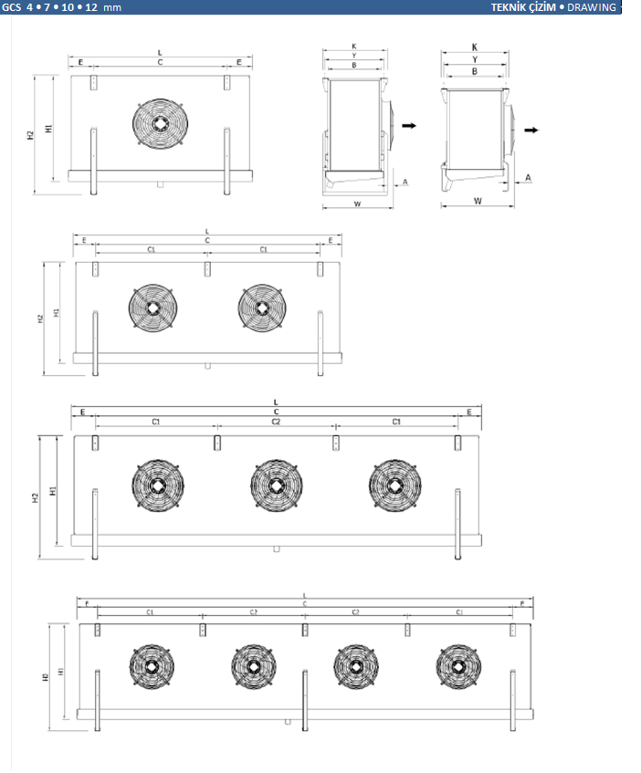**

**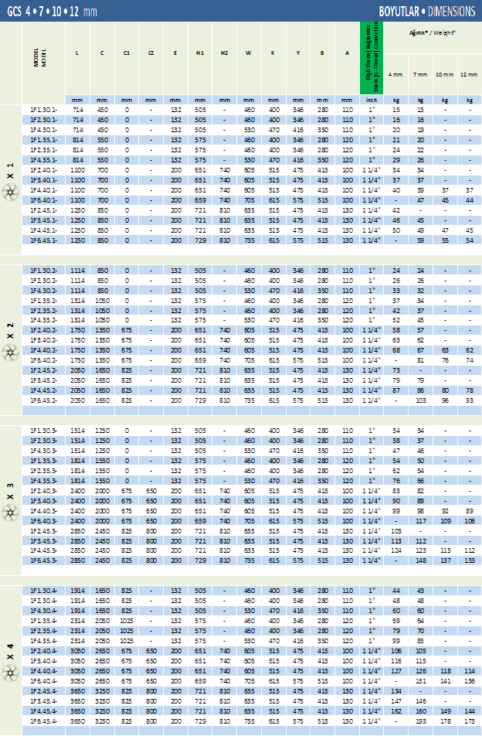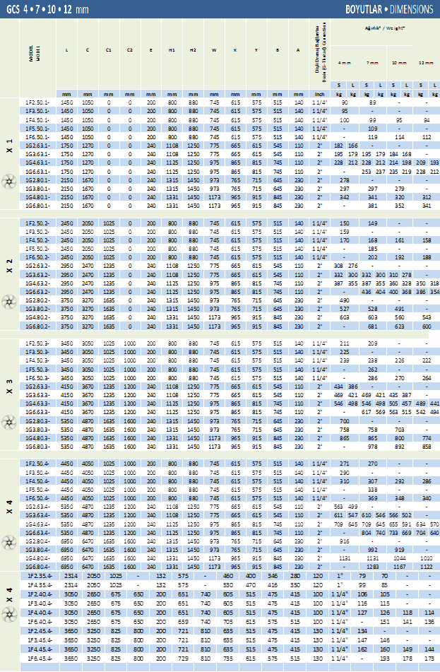**

## Electrical Connection

The electrical connection must comply with the relevant instructions and ground wires must be installed correctly.

* The wiring of fans should be done in accordance with the related rules.
* The main power supply cable should be determined according to electrical power requirements of the product specified on the label.
* A protection thermal relay should be used where absent for the operational protection of fan.
* Electrical wiring connections/junction should be under protection with minimum IP54 class boxes.

|  |  |
| --- | --- |
|  | **Risk of injury by electric shock** |

When connecting the electronic control to the power supply, injuries by electric shock are possible because of the voltage supply.

* All electrical connections on the product must be made by a qualified electrician in accordance with the electrical engineering rules.
* The main power switch should be turned off unless needed before a repairing/maintenance action.

# OPERATION

## Initial Commissioning

Before running the unit for the first time, be sure that all guards, motor mountings and electrical covers are secure, installation and electrical connection are done properly, internal wiring is kept away from the fans and the fans can rotate freely.

Make sure that all the mechanical connections are done in accordance with the rules. Piping is consistent with the guidelines. Before the start-up you may run the fans individually to make sure that they are running properly. Turn on the fluid valves and let the fluid flow right before running the fans. In case you may encounter any problem or disfunction please refer to the manufacturer for the resolution of the problem.

## Regular Commissioning

If the product is stationary for long periods in a humid atmosphere, the fans must be switched ON for **minimum of four hours in every month** to remove any moisture that may have condensed within the motors.

While the fans are running, anything that could pass through the finger guards, like a piece of cloth or long hair, must be kept away from the fans.

* Switch on the main power switch
* Make sure that the expansion device if fed by refrigerant.
* Switch on the fans.
* Defrost and heating systems should be checked and ensured that its work.
* Alternating operating states, e.g. usage changes at the set-up point, must also be considered. The defrosting frequency can be influenced by effects on the air side.
* Defrosting the unit with proper timing guarantees continuous operational reliability and the prevention of inaccessibilities that could result in a shutdown and disruptions. As the local conditions have a very big influence on the unit's performance and the need for defrosting, the operation must be checked regularly and settings of defrost period and the duration should be adjusted according to a monitoring of frost and/or icing on the heat exchanger at least 2 weeks in operation.
* Unless taking necessary measures could result in ice formation within the product’s drainage system. Part of the drainage system in cold room must be insulated. The use of flexible heater within the drainage pipe to prevent icing is recommended for room temperatures below zero degree celcius.

|  |  |
| --- | --- |
|  | **Stay away from the air direction of the fans while the fans are running.** |
|  | **Do not maintain or repair the product during operation** |

|  |  |
| --- | --- |
|  |  |

There is a risk of water freezing in the heat exchanger system in winter conditions. If the air temperature is too low, you should use antifreeze or you should never leave the heat exchanger inactive and filled. Otherwise the heat exchangers can be damaged. Adding antifreeze to the heat exchanger water keeps the freezing temperature lower.

|  |  |
| --- | --- |
|  |  |

Since it is not possible to drain all of liquid from the system, coolers using water and water based liquids, must be protected against freezing by adding adequately amount of antifreeze (glycol) to the water. On the other hand, glycol amount should be checked to not decrease.

|  |  |
| --- | --- |
|  |  |

It must be chosen 7-10 °C lower temperature in order to provide safely antifreeze (glycol) ratio.

|  |  |
| --- | --- |
| **Mixture Freezing Points For Different Antifreeze Ratios** | |
| **Volumetric Mixing Ratio** | **Freezing Temperature** |
| %100 Water | 0 °C |
| % 90 Water + % 10 Glycol | -3 °C |
| % 80 Water + % 20 Glycol | -7 °C |
| % 70 Water + % 30 Glycol | -14 °C |
| % 60 Water + % 40 Glycol | -22 °C |
| % 50 Water + % 50 Glycol | -33 °C |
| % 40 Water + % 60 Glycol | -48 °C |

Referans: ASHRAE

## Defrost System

### Defrost Control

* The defrosting process is started at pre-set intervals or as required.
* The process completion must be ensured twice (time/temperature and temperature/time),
* For defrost operation (circulation air, electric, hot gas (optional)) the correct on-site

Installation of the defrosting sensor must be ensured.

* The defrost probe temperature set point of 35 °C and defrosting time of 30 minutes is recommended in case of room volume change of 1 time per 4 hours. In case of more frequent air volume change or very humid product please set the defrosting period to a shorter time.
* Before the defrost operation the system must be ensured that stopped by a PUMP-DOWN operation and all the refrigerant is evacuated from the cooler unit.

### Circulation Air Defrost

* With operation of the units at room temperatures in the plus range (plus-cold storage rooms) and evaporation temperatures t0 = 0 to -5°C.
* Circulation air defrosting is usually sufficient with shut-off working fluid-carrying lines the required defrosting heat is generated by the fan heat flow and the air temperature in the plus range. But it also applies here: the refrigerating operation may be restarted, as described, only after complete defrosting.

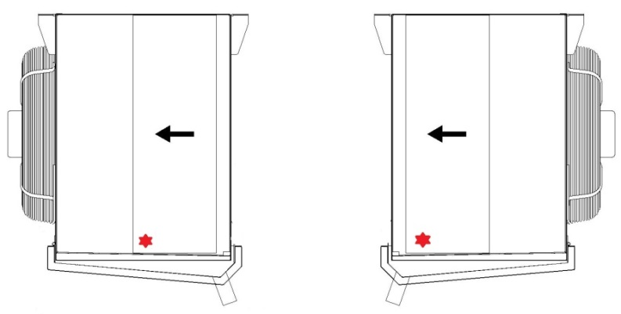

Proposed defrosting sensor positioning

### Electric Defrost

* With several units per room with electric defrosting alternating defrosting should be avoided, as otherwise reciprocal influences can have a negative effect here.
* Defrost may result in a slight increase in the surface and ambient temperatures. High surface temperature during drip time may cause humidity release to the room.
* Group defrosting is recommended instead of alternating. Several units are grouped here in a defrosting group. If a group is in defrost, the other groups must be switched off.
* A separate control of the coil and tray defrosting is possible (see note in electric connection plan).
* With average usage conditions a reduced defrosting capacity in the coil can be adjusted with a simple wiring change.

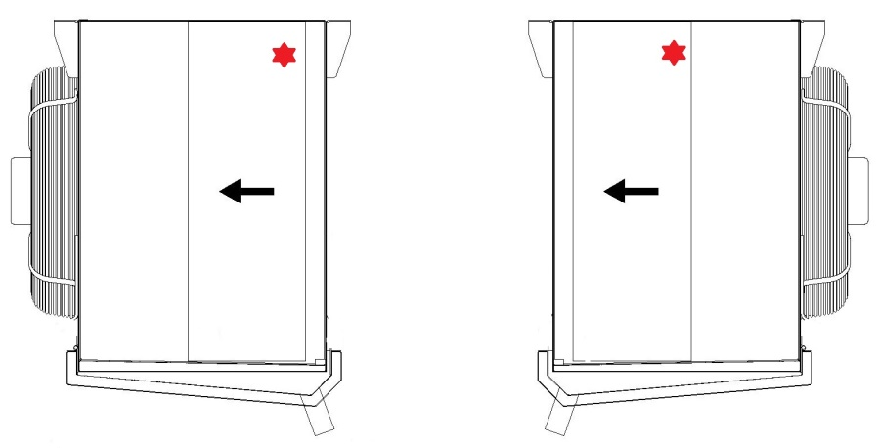

Proposed defrosting sensor positioning

### Hot Gas Defrost

* With defrosting hot gas, it must be ensured that at the point of defrosting enough other consumers are in the cold operation so that a big enough hot gas volume is available.
* The reciprocal influences of units in the refrigeration and cooling units in defrosting operation in conjunction with short defrosting times with hot gas operation are therefore limited to a low range of effect. These influences result on one hand from the extraction of the heat from the units to be defrosted and therefore in a defrost delay, and on the other hand in an additional stress with heat and moist air on the units in cooling/refrigerating operation.

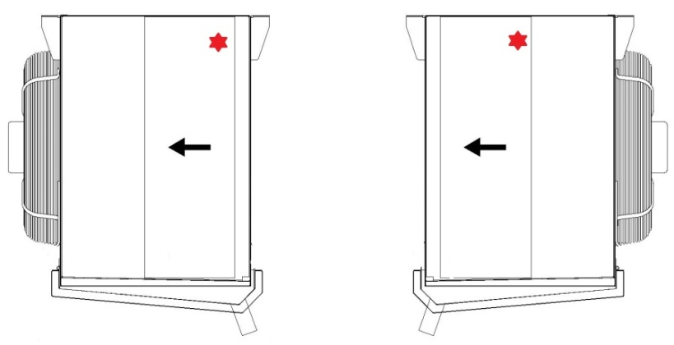

Proposed hot gas defrosting sensor positioning

### Water Defrost

* Actual defrost times must be determined from careful observation of defrost operation and adherence to the previously mentioned guidelines.
* Frost is usually heaviest on the air-entering side of the coil, and inspection of fins on this side can usually be used to determine if complete defrost has occurred.
* Periodic observation of the defrost cycle throughout the year is necessary to maintain a properly operating defrost system.
* If more than 20-30 minutes is required to completely remove frost, it is an indication that something may be wrong, such as inadequate water supply.
* The frequency of defrosting will seldom exceed once per day for storage rooms with average traffic. Small rooms with heavy service may require a defrost cycle twice per day and only in unusual circumstances will more than two be required.
* Water flow rate is controlled by adjusting the balancing valve at each unit. Adjust flow rate to fully saturate the coil fin surfaces in defrost water, making sure not to overflow the distribution pan, which can result in undesirable splashing.
* In some areas, the water pressure may become very low during daytime hours due to usage in the same building or neighbourhood. In such instances, it may be necessary to set the timer to defrost when adequate water pressure is available.

|  |  |
| --- | --- |
|  | Water supply should be pressurized between 1 bar and 1,5 bar. |

|  |  |
| --- | --- |
|  | |
| For the units with water defrost application, minimum  20 cm distance is recommended between the drain pipe  and the elbow.. | cid:image002.png@01D32D4E.A6DB8660 |

## UV-C Lamp

UV-C lamp works with direct irradiation. With its action, you can obtain a strong microbial load reduction, both on air and in all surfaces irradiated (Bacillus, Coli, Clostridium, Legionella, Vibrio, Salmonella, Pseudomonas, Staphylococcus, Streptococcus, molds, virus, etc.). UV-FCU-CL disinfects the surface in the section between the fan and the heat exchangers, radiating directly the air and removing all bacteria and viruses, such as influenza, that can be dragged by bacteria itself, or by micro -airborne droplets.

## Shutting Down

Fan connection must be disconnected and working fluid circulation must be stopped to shut the product down.

|  |  |
| --- | --- |
|  | Danger of cutting off, pulling in!  There is a danger of cutting off fingers on the rotating fan blades, injury hazard for the hands and pulling in danger for loose elements such as hair, necklaces or clothing parts. |
|  | Do not operate fans without guard grille. Pinch/trap point hazard!  With automatic fan start during maintenance work there is a danger of pinching/trap- ping for the hands and fingers. |
|  | **After shutting the unit down, the operating pressure must be observed whether the operating pressure exceeds maximum operating pressure or not.** |
|  | **Before touching, it is recommended to ensure that the headers and the connection pipes are neither too hot nor too cold due to working conditions of the fluid inside.** |

The operation must be stopped and the supplier must be informed in case of any unusual working condition, such as abnormal operating noise. Intensive vibrations due to out-of- balance running of the fans may lead to outage.

Maintenance must not be performed while the product is in use ***(See part 8 for details).***

|  |  |
| --- | --- |
|  | **Recommended starting value for fans is 6 per hour while maximum is 10.** |

# MAINTENANCE

## Maintenance Intervals

Maintenance operation is to be performed by qualified personnel only. Please be sure that safety regulations and the worker's protection rules are obeyed during the maintenance and service (DIN EN 50110).

The fluid circulation must be stopped and it must be ensured that no electrical supply connection exists during maintenance. It is advisable to wait till the product comes to thermal balance with its surroundings if possible.

|  |  |
| --- | --- |
|  | If the tubes within the product or the connection pipes are to be repaired, the refrigerant in the line must be evacuated beforehand. |

## Fan motor Maintenance

* Regarding the bearings, the fans are maintenance-free for 30000-40000 hours under normal operating conditions.
* If the fans are to be maintained, the instruction manual prepared by the fan manufacturer must be followed. Please contact manufacturer when needed.
* After maintenance is performed, ensure that no tools or other foreign materials are left in or near the product.

|  |  |
| --- | --- |
|  | Follow to Initial Commissioning before operating the product after maintenance. |

## Maintenance of UV-C Lamp

* The lifetime of the UV-C lamp is 18000 hours.
* Since the light emitted from the lamp cannot be seen with the naked eye, extreme care should be taken during lamp maintenance.
* Before performing lamp maintenance, always disconnect the power supply.
* If the UV-C lamp becomes dusty or dirty, clean it with a clean cloth and alcohol.
* If maintenance will be done to UV-C lamps, the user manual prepared by the lamp manufacturer should be followed. Please consult the manufacturer when necessary.
* After maintenance, make sure that no tools or foreign objects are left around the product.

## Periodical Controls (Once a year)

* Corrosion on the fins and tubes should be inspected. If the tubes are worn-out, leakage may occur.
* The pipeline must be controlled for damage and leakage.
* Mechanical and electrical connections of the fans must be checked. Fans must be able to rotate freely and finger guard must be stable.
* All the fixings, especially fan motor mountings and product installation fixings must be ensured to be secure.

## Cleaning

* Accessories with hinged can make cleaning easier.

***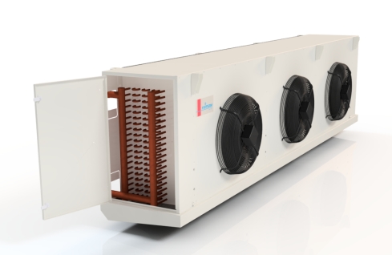***

***Cleaning the fins***

* One of the effective methods to clean up the fins is to spray pressurized air. This action should be conducted after stopping the fans and turning off the fluid supply valves. The air jet should be provided to be parallel to the fins for the best cleaning results.
* Fins could also be cleaned up by pressurized water jet. The water jet should be provided to be parallel to the fins for best result. . This action should be conducted after stopping the fans and turning off the fluid supply valves. The cleaning action should be carried out inside-out. Some harmless solvent/detergents could be added to the water to ease the removal of hardened dirt. Any known corrosive/aggressive chemical should be avoided to be used in cleaning action.
* The wiring and fans should not be wetted during the cleaning process

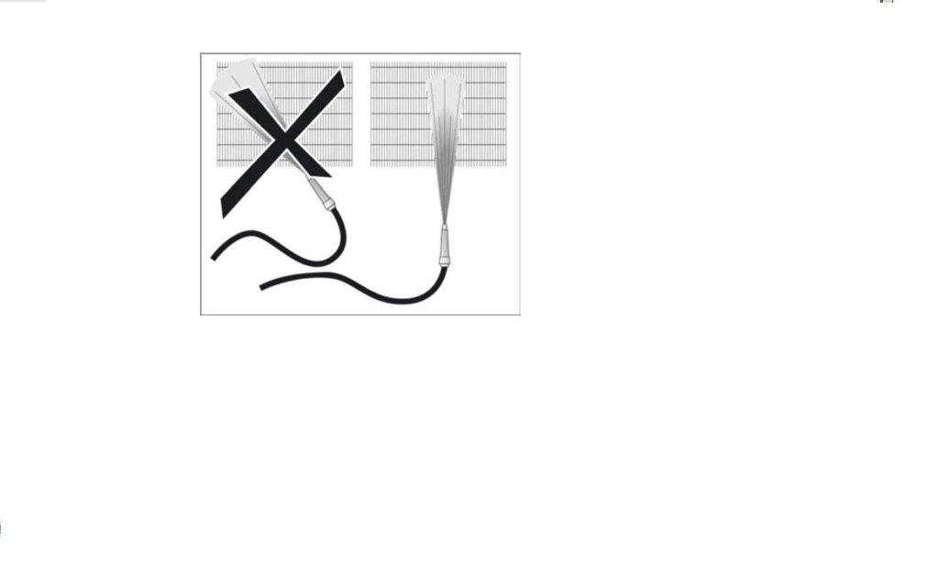

**The cleaning operation must be done parallel to fin surface.**

***Cleaning Up the Fans***

* Fans should be cleaned with the aid of pressurized air and a soft brush.
* Electrical connections and fan motors should not be wetted during cleaning

# TROUBLESHOOTING

|  |  |  |
| --- | --- | --- |
| ***Faults*** | ***Possible Causes*** | ***Remedy*** |
| Unit capacity not achieved | Fans are not running properly | Repair or change fans |
| Polluted coils | Clean |
| Different brine working pressure | Adjust brine pressurising values to reference values |
| Heat exchanger is very dirty, frosted, iced on the air side | Clean, defrost heat exchanger |
| Fan motor is not working | Fan blade stuck | Enable fan to rotate freely |
| Power supply cut off | Fix power supply |
| Unusual noise | Defective Fan bearing | Replace bearing or fans |
| Vibration | Defective fan blades | Modify or change fan blades |
| Fan fixtures loosened | Tighten the fixtures |
| Working fluid escaping | Unit working fluid-carrying components leaking | Switch off working fluid feed and fans, close leak |
| UV-C lamp not working | No Electrical Connection | Check the electric connectıon |
| Lamp resistor broken | Replace the lamp |

**